Chapter 3 Living systems
extra worksheet 4: Arthritis
Science understanding, Science as a human endeavour
Many older people have pain in their joints caused by a disease called arthritis. Over 100 different diseases are grouped together under the name arthritis. Two of the common diseases in this group are osteoarthritis and rheumatoid arthritis.

Osteoarthritis
In osteoarthritis, the cartilage covering the ends of the bones at a joint wears down and becomes thin. The ends of the bones are not protected and they cannot move easily over one another. When bone rubs on bone, the joint is stiff and painful. Osteoarthritis is most common in people over the age of 45, but younger people can be affected.

Rheumatoid arthritis
Rheumatoid arthritis is caused by a person’s own body causing damage to the cartilage of the joints. White blood cells that should be fighting disease destroy the healthy cartilage of the joints. The joints become swollen as more blood comes to the area and become stiff and painful as the cartilage is destroyed. The effects of this are shown in Figure 3.4.1. Medical scientists do not yet understand why the body starts destroying its own tissues.
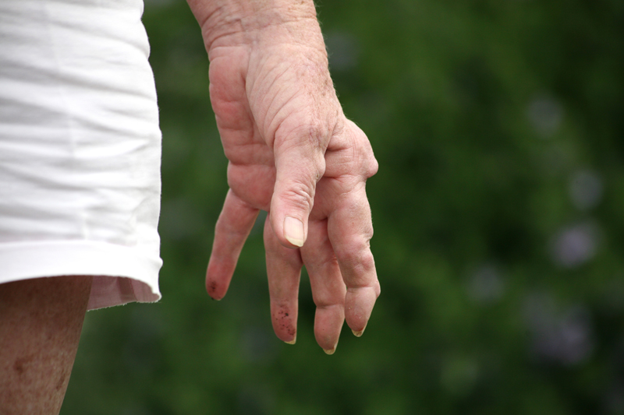
Figure 3.4.1
The joints of this woman’s hand are swollen and twisted by the effects of rheumatoid arthritis.

Rheumatoid arthritis can affect people of any age—even babies. In young people the disease is known as juvenile arthritis. For some children, juvenile arthritis has little effect on their lives. Other children experience a lot of pain. Their ability to move around normally and carry out everyday activities is affected.

Questions
1 State how many diseases are grouped together under the name arthritis.

2 Describe what cartilage is and its function.

3 Compare osteoarthritis and rheumatoid arthritis.

4 Explain why arthritis is painful.

5 Propose why it is difficult to find a cure for arthritis.

